DR. BABASAHEB AMBEDKAR MARATHVADA
UNIVERSITY, AURANGABAD
PROJECT REPORT
on
“PYTHON CODE EDITOR”

For the Degree of

Bachelor of Engineering in

Information Technology
By
ADITYA MALODE(4320)
SAHIL KHAN PATHAN(4326)
AKANKSHA NIKAM(4324)
SANDHYA SAKALKAR(4333)
Under the Guidance of
Prof. Sandeep Gite

Department of Information Technology
Matsyodari Shikshan Sanstha’s
College of Engineering & Technology, Jalna
Maharashtra State, India
CERTIFICATE
This is to certify that the project entitled “Python Code Editor”, which is being submitted herewith for the award of the Bachelor of Engineering in Information Technology of Dr. Babasaheb Ambedkar Marathwada University, Lonere. This is the result of the original research work and contribution by Aditya Malode(4320), Sahil Khan Pathan(4326), Akanksha Nikam(4324), Sandhya Sakalkar(4333) under my supervision and guidance. The work embodied in this project has not formed earlier for the basis of the award of any degree or compatible certificate or similar title of this for any other diploma/examination body or university to the best of my knowledge and belief.

Place: Jalna
Date:

Prof. Sandip Gite Prof. G.P.Chokote
Guide Head
Dept. of Computer Science & Engg. Dept. of Computer Science & Engg.

DR. S.K.Biradar
Principal
MSS’s College of Engineering & Technology
Jalna

DECLARATION
I hereby declare that I have formed, completed and written the project entitled “Python Code Editor”. It has not previously submitted for the basis of the award of any degree or diploma or similar title of this for any other diploma/examining body or university.

Place: Jalna Aditya Malode(4320)
Sahil Khan Pathan(4326)
Akanksha Nikam(4324)
Sandhya Sakalkar(4333)
Date: B.E. Computer Science & Engineering

INDEX

Sr. No. Title Page No.

- Introduction …....………………….…………………………………..01

- Technology…....………………….……...……………………………..02

- Technology Used…....………………...………………………………..03

- Code…....………………….……….……………….…………………..04

- Output…....………………….……….……….………………………..15

- Conclusion…....………………….…….………..……………………..18

- References…....………………….………………...…………………..19

ACKNOWLEDGMENT

It gives us an intense pleasure as we have privilege to submit our Project Report as a part of final year of Bachelor Degree in Information Technology, Engineering.

In the preparation of this project, we have received valuable assistance from several splendid personalities. Their mention with gratitude is essential here.

At the very outset, we would like to thank Prof. Prof. Sandip Gite , Guide for her moral support and continuous encouragement and we are also Grateful to Prof. Prof. G.P.Chokote of Information Technology Department who is source of inspiration in several undertaking. His assistance to put in high sprit.

At the outset, we would like to thank Principal. S.K.Biradar, MSS’s College of Engineering & Technology, Jalna

ABSTRACT

Python is a modern, easy-to-learn, object-oriented programming language. It has a powerful set of built-in data types and easy-to-use control constructs. Since Python is an interpreted language, it is most easily reviewed by simply looking at and describing interactive sessions. It is used in vast number of applications due to the various standard libraries that come along with it and its capacity to integrate with other languages and use their features. Python can be used for scripting, web scraping, and creating data sets. It’s popular in the scientific community for scientific computing; there are libraries that make it easy to share academic code projects in Python. Python is a web programming language, so it interfaces with the internet. It knows how to receive and send web requests and talk to databases. This paper describes the main features of Python programming, loops and control statements in python then discusses applications of Python programming.

A python code editor is a standalone editing application to write and edit programs.it is the fundamental coding tool that is used by every developer.Pyhton code editors are easy to use and same as the python code editor.This code editor i.e the python code editor is easy to use and with the most useful tools imbedded with the libraries and the directories. The python code editor works or we can say the it uses the programming language Python.The python code editor is used for coding purpose and for making the projects and for running the code made using the language python.

INTRODUCTION

Python code editor is the open source code editor that helps the students as well as the learners to focus on the python programming language.It is easy to learn and implement on this code editor.In this python code editor there are many features including with the updates made by the developer.In this code editor we are free to write the code and also run.It is the most easy as well as the most interactive editor which runs the python language as priority. , it is most easily reviewed by simply looking at and describing interactive sessions. It is used in vast number of applications due to the various standard libraries that come along with it and its capacity to integrate with other languages and use their features.
This python code editor consist of many technologies used just as the tkinter,subprocesses etc.It consist of the the mainy different types of the menus as on output screen.the main menu is included with the main menu , color theme , clear and run module or we can say that buttons.and those main menus consist of many submenues.

The menu button consist of the new ,Open Save,Save As,Exit buttons with the shortcut keys included.The second button consist of color themes and with different color themes that changes according to it .The clear buton clears the screen of input as well as the output.The Exit button helps to exit the python code editor.

The Python code editor helps the learner to get aware about this python code editor with all the benefits included in the original python code editor with all the facilities and with less complexity and I the easy way to the beginners to code the fast and with more effictevely.

TECHNOLOGY

The technology used in this project is the popular programming language PYTHON.It was initially designed by python software foundation. Python is the programming language that lets you work quickly and integrate systems more efficiently. Python is high level language,interpreted interactive and object oriented scripting language.Python is desigh to be highly readable.
- Pyhton is interpreted
- Python is interactive
- Python is object oriented
- Easy to learn

Python code editor is the open source code editor that helps the students as well as the learners to focus on the python programming language.It is easy to learn and implement on this code editor.In this python code editor there are many features including with the updates made by the developer.In this code editor we are free to write the code and also run.It is the most easy as well as the most interactive editor which runs the python language as priority. , it is most easily reviewed by simply looking at and describing interactive sessions. It is used in vast number of applications due to the various standard libraries that come along with it and its capacity to integrate with other languages and use their features.
This python code editor consist of many technologies used just as the tkinter,subprocesses etc.It consist of the the mainy different types of the menus as on output screen.the main menu is included with the main menu , color theme , clear and run module or we can say that buttons.and those main menus consist of many submenues.

TECHNOLOGY USED

Editor=Notepad

Notepad++.

WordPad.

Virtualstudiocode.

InternetExplorer.

Chrome.

Microsoftword.

WPSOffice.

Python IDLE.

WEBSITE CODE

from tkinter import*
from tkinter import messagebox,filedialog
import subprocess
class Vs_code:
def __init__(self,root):
self.root=root
self.root.title("Python Code Editor")
self.root.geometry("1350x700+0+0")

self.path_name=''
self.color_theme=StringVar()
self.color_theme.set('Light Default')
self.font_size=18

#=====================Menu Icons ================

self.new_file_icon=PhotoImage(file='icons/new.png')
self.open_file_icon=PhotoImage(file='icons/open.png')
self.save_file_icon=PhotoImage(file='icons/save.png')
self.save_as_file_icon=PhotoImage(file='icons/save as.png')
self.exit_file_icon=PhotoImage(file='icons/exit.png')

self.light_default_icon=PhotoImage(file='icons/light default.png')
self.light_plus_icon=PhotoImage(file='icons/light plus.png')
self.dark_icon=PhotoImage(file='icons/dark.png')
self.red_icon=PhotoImage(file='icons/red.png')
self.monokai_icon=PhotoImage(file='icons/monkai.png')
self.night_blue_icon=PhotoImage(file='icons/night blue.png')

#=====================Menus======================
Mymenu=Menu(self.root)

Filemenu=Menu(Mymenu,tearoff=False)
Filemenu.add_command(label='New File',image=self.new_file_icon,compound=LEFT,accelerator='Clt+N',command=self.new_file)
Filemenu.add_command(label='Open File',image=self.open_file_icon,compound=LEFT,accelerator='Ctl+O',command=self.open_file)
Filemenu.add_command(label='Save',image=self.save_file_icon,compound=LEFT,accelerator='Ctl+S',command=self.save_file)
Filemenu.add_command(label='Save as',image=self.save_as_file_icon,compound=LEFT,accelerator='Ctl+Alt+s',command=self.save_as_file)
Filemenu.add_command(label='Exit',image=self.exit_file_icon,compound=LEFT,accelerator='Ctl+Q',command=self.exit_function)

color_theme=Menu(Mymenu,tearoff=False)
color_theme.add_radiobutton(label='Light Default',value='Light Default',variable=self.color_theme,image=self.light_default_icon,compound=LEFT,command=self.color_change)
color_theme.add_radiobutton(label='Light Plus',value='Light Plus',variable=self.color_theme,image=self.light_plus_icon,compound=LEFT,command=self.color_change)
color_theme.add_radiobutton(label='Dark',value='Dark',variable=self.color_theme,image=self.dark_icon,compound=LEFT,command=self.color_change)
color_theme.add_radiobutton(label='Red',value='Red',variable=self.color_theme,image=self.red_icon,compound=LEFT,command=self.color_change)
color_theme.add_radiobutton(label='Monokai',value='Monokai',variable=self.color_theme,image=self.monokai_icon,compound=LEFT,command=self.color_change)
color_theme.add_radiobutton(label='Night Blue',value='Night Blue',variable=self.color_theme,image=self.night_blue_icon,compound=LEFT,command=self.color_change)

Mymenu.add_cascade(label='File',menu=Filemenu)
Mymenu.add_cascade(label='Color Theme',menu=color_theme)
Mymenu.add_command(label='Clear',command=self.clear_all)
Mymenu.add_separator()
Mymenu.add_command(label='Run',command=self.run)
self.root.config(menu=Mymenu)

#==================Menu Ends Here==============================

#==================EditorFrame=============================

EditorFrame=Frame(self.root,bg="white")
EditorFrame.place(x=0,y=0,relwidth=1,height=500)

Scrolly=Scrollbar(EditorFrame,orient=VERTICAL)
Scrolly.pack(side=RIGHT,fill=Y)
self.txt_editor=Text(EditorFrame,bg='white',font=('times new roman',self.font_size),yscrollcommand=Scrolly.set)
self.txt_editor.pack(fill=BOTH,expand=1)
Scrolly.config(command=self.txt_editor.yview)

#==================OutputFrame============================

outputFrame=Frame(self.root,bg="white")
outputFrame.place(x=0,y=500,relwidth=1,height=200)

Scrolly=Scrollbar(outputFrame,orient=VERTICAL)
Scrolly.pack(side=RIGHT,fill=Y)
self.txt_output=Text(outputFrame,bg='white',font=('times new roman',18),yscrollcommand=Scrolly.set)
self.txt_output.pack(fill=BOTH,expand=1)
Scrolly.config(command=self.txt_output.yview)

#===================Shortcuts==============================

self.root.bind('<Control-plus>',self.font_size_inc)
self.root.bind('<Control-minus>',self.font_size_dec)
self.root.bind('<Control-o>',self.open_file)
self.root.bind('<Control-n>',self.new_file)
self.root.bind('<Control-s>',self.save_file)
self.root.bind('<Control-Alt-s>',self.save_as_file)
self.root.bind('<Control-q>',self.exit_function)

#===================All Functions===========================

def font_size_inc(self,event=None):
self.font_size+=1
self.txt_editor.config(font=('times new roman',self.font_size))

def font_size_dec(self,event=None):
self.font_size-=1
self.txt_editor.config(font=('times new roman',self.font_size))

def run(self):
if self.path_name=='':
messagebox.showerror('Error',"please save the file to execute the code",parent=self.root)
else:
command=f'python {self.path_name}'
run_file=subprocess.Popen(command,stdout=subprocess.PIPE,stderr=subprocess.PIPE,shell=True)
output,error=run_file.communicate()
self.txt_output.delete('1.0',END)
self.txt_output.insert('1.0',output)
self.txt_output.insert('1.0',error)

def clear_all(self):
self.txt_editor.delete('1.0',END)
self.txt_output.delete('1.0',END)

def color_change(self):
if self.color_theme.get()=='Light Default':
self.txt_editor.config(bg='#ffffff',fg='#000000')
self.txt_output.config(bg='#ffffff',fg='#000000')
if self.color_theme.get()=='Light Plus':
self.txt_editor.config(bg='#e0e0e0',fg='#474747')
self.txt_output.config(bg='#e0e0e0',fg='#474747')
if self.color_theme.get()=='Dark':
self.txt_editor.config(bg='#2d2d2d',fg='#c4c4c4')
self.txt_output.config(bg='#2d2d2d',fg='#c4c4c4')
if self.color_theme.get()=='Red':
self.txt_editor.config(bg='#ffe8e8',fg='#2d2d2d')
self.txt_output.config(bg='#ffe8e8',fg='#2d2d2d')
if self.color_theme.get()=='Monokai':
self.txt_editor.config(bg='#d3b774',fg='#474747')
self.txt_output.config(bg='#d3b774',fg='#474747')
if self.color_theme.get()=='Night Blue':
self.txt_editor.config(bg='#6b9dc2',fg='#ededed')
self.txt_output.config(bg='#6b9dc2',fg='#ededed')

def exit_function(self,event=None):
self.root.destroy()

def new_file(self,event=None):
self.path_name=''
self.txt_editor.delete('1.0',END)
self.txt_output.delete('1.0',END)

def save_file(self,event=None):
if self.path_name=="":
self.save_as_file()
else:
fp=open(self.path_name,'w')
fp.write(self.txt_editor.get('1.0',END))
fp.close()

def open_file(self,event=None):
path=filedialog.askopenfilename(filetypes=[('Python Files','*.py')],defaultextension=('.py'))
if path!='':
self.path_name=path
fp=open(self.path_name,'r')
data=fp.read()
self.txt_editor.delete('1.0',END)
self.txt_editor.insert('1.0',data)
fp.close()
def save_as_file(self,event=None):

path=filedialog.asksaveasfilename(filetypes=[('Python Files','*.py')],defaultextension=('.py'))
if path!='':
self.path_name=path
fp=open(self.path_name,'w')
fp.write(self.txt_editor.get('1.0',END))
fp.close()

root=Tk()
obj=Vs_code(root)
root.mainloop()

OUTPUT
THE MAIN MENU:
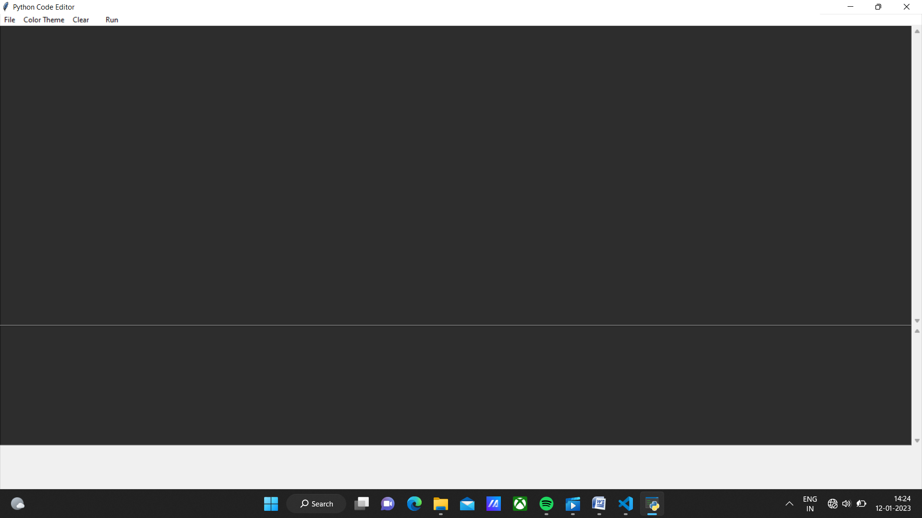

FILE MENU:
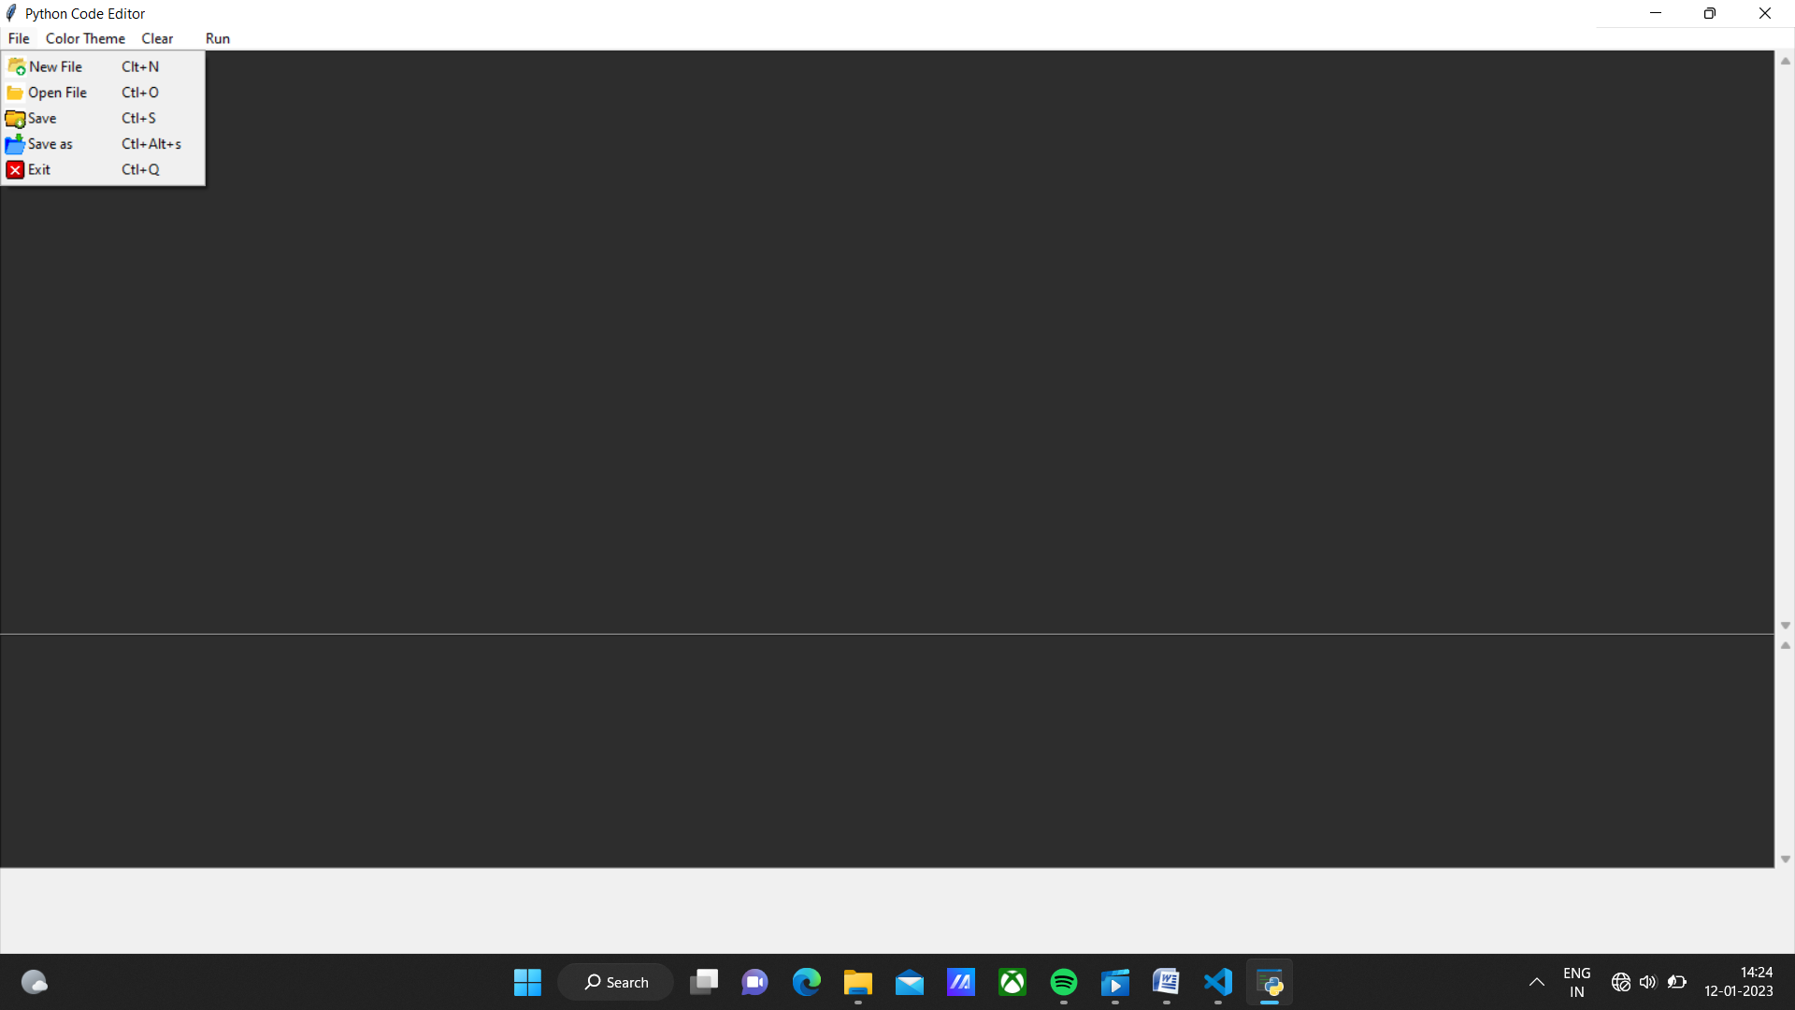

COLOR THEMES:
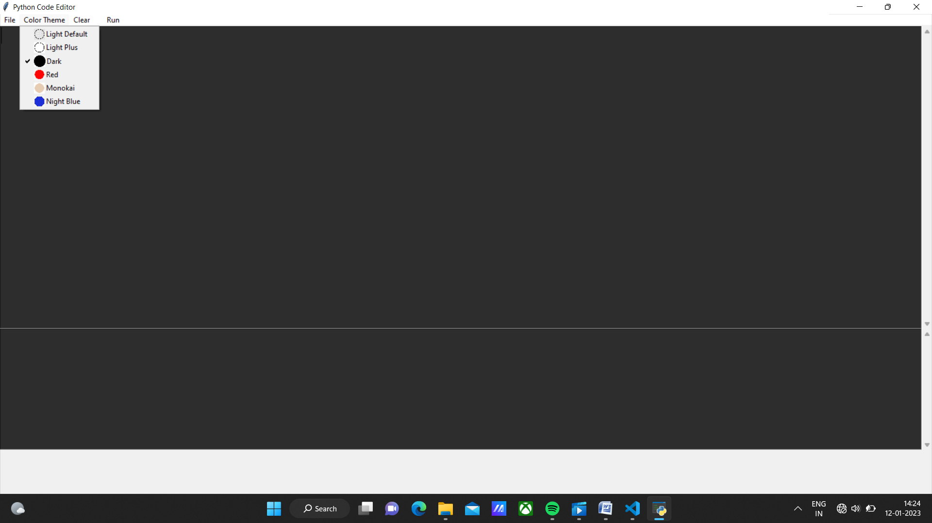

FILE WINDOW

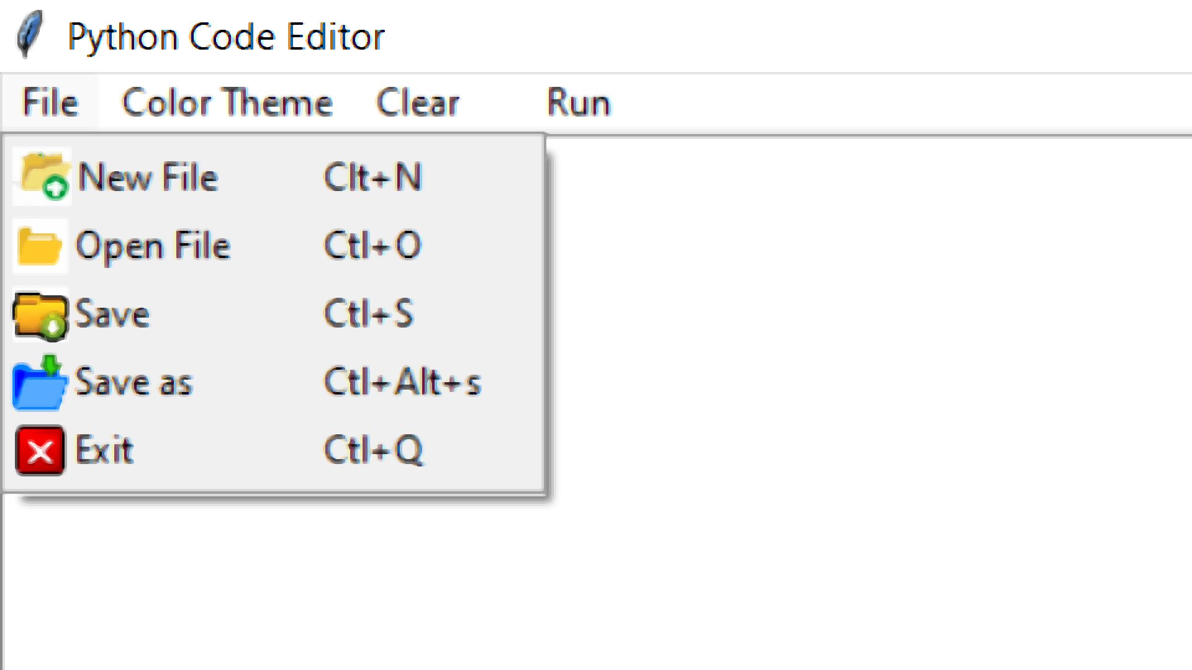

THEME WONDOW:
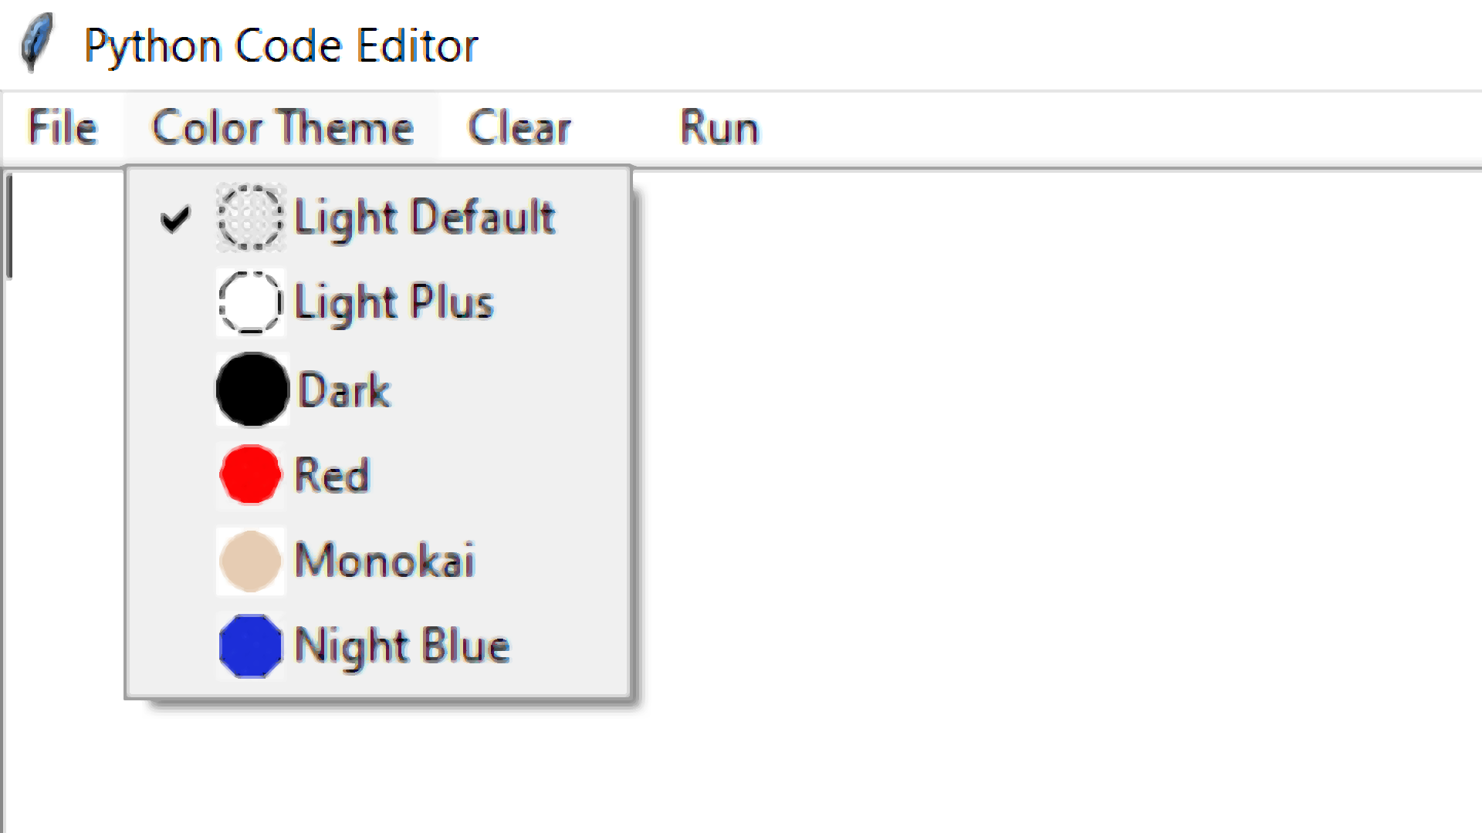

ERROR WINDOW:

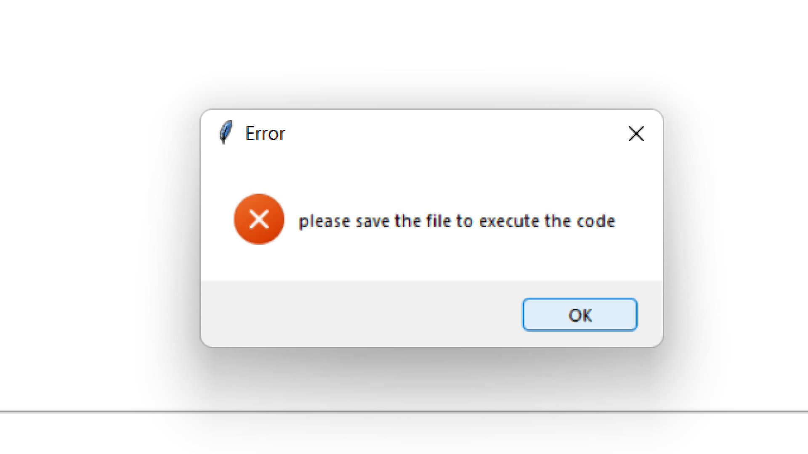

CONCLUSION
The benefit provides a computerized version of the python code editor which will benefit the student for the learning process.
It makes the entire process online where student as well as the staff can code and get the problems solved or can use it to learn the python coding. It also has a facility for the learner where the learner can write the code and can run it as well if there is any error the error would be shown in the terminal and can be determined.

REFRENCES

- https://in.pinterest.com/

- https://www.python.org/

- https://www.geeksforgeeks.org/python-tkinter-tutorial/

- https://docs.python.org/3/library/tkinter.html

